Blinkit Analysis
- See all the data imported:
SELECT * FROM blinkit_data
- DATA CLEANING:
Cleaning the Item_Fat_Content field ensures data consistency and accuracy in analysis. The presence of multiple variations of the same category (e.g., LF, low fat vs. Low Fat) can cause issues in reporting, aggregations, and filtering. By standardizing these values, we improve data quality, making it easier to generate insights and maintain uniformity in our datasets.
UPDATE blinkit_data
SET Item_Fat_Content =
CASE
WHEN Item_Fat_Content IN ('LF', 'low fat') THEN 'Low Fat'
WHEN Item_Fat_Content = 'reg' THEN 'Regular'
ELSE Item_Fat_Content
END;

After executing this query check the data has been cleaned or not using below query
SELECT DISTINCT Item_Fat_Content FROM blinkit_data;

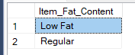

A. KPI’s
1. TOTAL SALES:
SELECT CAST(SUM(Total_Sales) / 1000000.0 AS DECIMAL(10,2)) AS Total_Sales_Million
FROM blinkit_data;
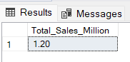
2. AVERAGE SALES
SELECT CAST(AVG(Total_Sales) AS INT) AS Avg_Sales
FROM blinkit_data;
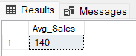
3. NO OF ITEMS
SELECT COUNT(*) AS No_of_Orders
FROM blinkit_data;
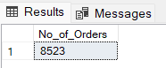
4. AVG RATING
SELECT CAST(AVG(Rating) AS DECIMAL(10,1)) AS Avg_Rating
FROM blinkit_data;
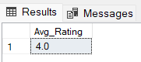

B. Total Sales by Fat Content:
SELECT
`Item_Fat_Content`,
CAST(SUM(`Total Sales`) / 1000 AS DECIMAL(10,2)) AS `Total Sales Thousands`,
CAST(SUM(`Total Sales`) / COUNT(*) AS DECIMAL(10,2)) AS `Avg Sales`,
CAST(AVG(Rating) AS DECIMAL(10,2)) AS `Avg Rating`,
COUNT(*) AS `No of Sales`
FROM blinkit_data
GROUP BY `Item_Fat_Content`
ORDER BY `Total Sales Thousands` DESC; 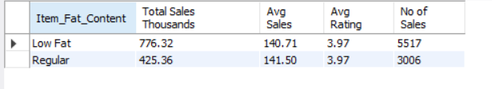

C. Total Sales by Item Type
SELECT
`Item Type`,
COUNT(*) AS Items_Sold_Count,
SUM(`Total Sales`) AS Total_Sales
FROM blinkit_data
GROUP BY `Item Type`
ORDER BY Total_Sales DESC;
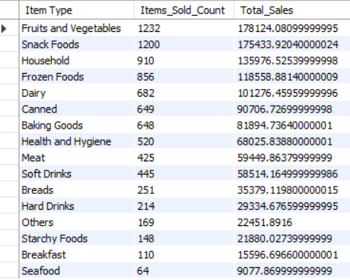

D. Fat Content by Outlet for Total Sales
SELECT
`Outlet Location Type`,
IFNULL(SUM(CASE WHEN `Item_Fat_Content` = 'Low Fat' THEN `Total Sales` END), 0) AS `Low Fat`,
IFNULL(SUM(CASE WHEN `Item_Fat_Content` = 'Regular' THEN `Total Sales` END), 0) AS `Regular`
FROM blinkit_data
GROUP BY `Outlet Location Type`
ORDER BY `Outlet Location Type`;

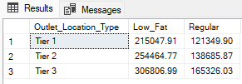
Query Explanations
This query aims to transform the blinkit_data table to display total sales (Total_Sales) for each combination of Outlet_Location_Type and Item_Fat_Content. The result will show Outlet_Location_Type as rows and Item_Fat_Content categories ("Low Fat" and "Regular") as columns. If there are no sales for a particular combination, the query will display 0 instead of NULL.
Detailed Explanation:
- Subquery
  - Aggregation:
sql
CopyEdit
SELECT
Outlet_Location_Type,
Item_Fat_Content,
CAST(SUM(Total_Sales) AS DECIMAL(10,2)) AS Total_Sales
FROM
blinkit_data
GROUP BY
Outlet_Location_Type,
Item_Fat_Content
    - Purpose: This subquery groups the data by Outlet_Location_Type and Item_Fat_Content, calculating the total sales for each combination.
    - CAST(SUM(Total_Sales) AS DECIMAL(10,2)): Sums the Total_Sales for each group and casts the result to a decimal with two decimal places for precision.
- PIVOT Operation:
  - Pivoting:
sql
CopyEdit
PIVOT
(
SUM(Total_Sales)
FOR Item_Fat_Content IN ([Low Fat], [Regular])
) AS PivotTable
    - Purpose: Transforms the rows of Item_Fat_Content into columns ([Low Fat] and [Regular]).
    - SUM(Total_Sales): Aggregates the Total_Sales for each Item_Fat_Content category within each Outlet_Location_Type.
- Main Query:
  - Selecting and Handling NULLs:
sql
CopyEdit
SELECT
Outlet_Location_Type,
ISNULL([Low Fat], 0) AS Low_Fat,
ISNULL([Regular], 0) AS Regular
FROM
PivotTable
ORDER BY
Outlet_Location_Type;
    - ISNULL([Low Fat], 0) AS Low_Fat: Replaces any NULL values in the [Low Fat] column with 0 and renames the column to Low_Fat.
    - ISNULL([Regular], 0) AS Regular: Similarly, replaces NULL values in the [Regular] column with 0.
    - ORDER BY Outlet_Location_Type: Sorts the final result set by Outlet_Location_Type.
Why Use ISNULL?
When performing a PIVOT operation, if a particular combination of Outlet_Location_Type and Item_Fat_Content doesn't exist in the data, the resulting cell will contain a NULL value. Using ISNULL(column)

E. Total Sales by Outlet Establishment
SELECT Outlet_Establishment_Year, CAST(SUM(Total_Sales) AS DECIMAL(10,2)) AS Total_Sales
FROM blinkit_data
GROUP BY Outlet_Establishment_Year
ORDER BY Outlet_Establishment_Year
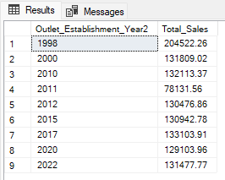

F. Percentage of Sales by Outlet Size
SELECT
Outlet_Size,
CAST(SUM(Total_Sales) AS DECIMAL(10,2)) AS Total_Sales,
CAST((SUM(Total_Sales) * 100.0 / SUM(SUM(Total_Sales)) OVER()) AS DECIMAL(10,2)) AS Sales_Percentage
FROM blinkit_data
GROUP BY Outlet_Size
ORDER BY Total_Sales DESC;

Query Explanation:
Outlet_Size: This column represents the size category of the outlet (e.g., Small, Medium, Large).
CAST(SUM(Total_Sales) AS DECIMAL(10,2)) AS Total_Sales:
- SUM(Total_Sales): Calculates the total sales for each Outlet_Size.
- CAST(... AS DECIMAL(10,2)): Formats the resulting sum to a decimal number with two decimal places for precision.
CAST((SUM(Total_Sales) * 100.0 / SUM(SUM(Total_Sales)) OVER()) AS DECIMAL(10,2)) AS Sales_Percentage:
- SUM(Total_Sales) * 100.0: Multiplies the total sales of the current Outlet_Size by 100 to prepare for percentage calculation.
- SUM(SUM(Total_Sales)) OVER():
  - SUM(Total_Sales): Within the GROUP BY context, this computes the total sales for each Outlet_Size.
  - SUM(... ) OVER(): The outer SUM combined with the OVER() clause calculates the grand total of all Total_Sales across all outlet sizes without collapsing the result set.
- SUM(Total_Sales) * 100.0 / SUM(SUM(Total_Sales)) OVER(): Divides the total sales of the current Outlet_Size by the grand total sales and multiplies by 100 to get the percentage contribution of each outlet size to the overall sales.
- CAST(... AS DECIMAL(10,2)): Formats the resulting percentage to two decimal places.

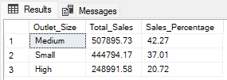

G. Sales by Outlet Location
SELECT Outlet_Location_Type, CAST(SUM(Total_Sales) AS DECIMAL(10,2)) AS Total_Sales
FROM blinkit_data
GROUP BY Outlet_Location_Type
ORDER BY Total_Sales DESC
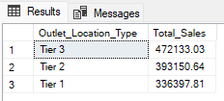

H. All Metrics by Outlet Type:
SELECT Outlet_Type,
CAST(SUM(Total_Sales) AS DECIMAL(10,2)) AS Total_Sales,
CAST(AVG(Total_Sales) AS DECIMAL(10,0)) AS Avg_Sales,
COUNT(*) AS No_Of_Items,
CAST(AVG(Rating) AS DECIMAL(10,2)) AS Avg_Rating,
CAST(AVG(Item_Visibility) AS DECIMAL(10,2)) AS Item_Visibility
FROM blinkit_data
GROUP BY Outlet_Type
ORDER BY Total_Sales DESC

